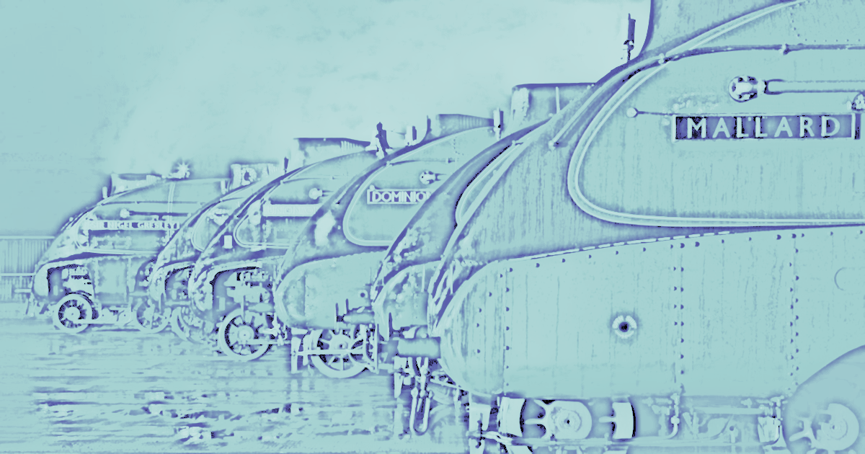
THE 25th ANNUAL COMBINED NORTHERN AND YORKSHIRE RHEUMATOLOGY MEETING

NATIONAL RAILWAY MUSEUM, YORK

WEDNESDAY SEPTEMBER 25th 2019

0830-0905 BREAKFAST, REGISTRATION AND COFFEE

0905-1025 CONCURRENT TRANSLATIONAL & CLINICAL CASE SESSION

Translational science
(6 x 10 minute abstracts, including questions)

Chair: Ed Vital
IL-17A Induces Distinct Functional Differences Between Two Novel Mesenchymal Stem Cell Populations Identified At The Human Enthesis
Tobias Russell^{1,2}, Abdulla Watad³, Charlie Bridgewood², Almas Khan⁴, Abhay S Rao⁴, Peter Loughenbury⁴, Peter Milner⁴, Robert Dunsmuir⁴, Richard Cuthbert², Ala Altaie², Elena Jones², Dennis McGonagle²
1 umtjwr@leeds.ac.uk, 2 Leeds Institute of Rheumatic and Musculoskeletal Medicine, Wellcome Trust Brenner Building, University of Leeds, St. James’s University Hospital, LS9 7TF, 3 Department of Medicine “B”, Zabludowicz Center for Autoimmune Diseases, Sheba Medical Center, Tel-Hashomer, Ramat Gan, Israel, 4 Leeds Teaching Hospitals NHS Trust

Macrophage subgroups distinguish knee osteoarthritis patients; innovative technology can now reveal their spatial localisation within the joint.
Amanda Thomson*^{1,2,5}, Matthew Wood*⁴, Ben Millar^{1,2,5}, Gillian Hulme^{2,3}, Andrew Fuller^{2,3}, David McDonald^{2,3}, Arthur Pratt^{1,2,5}, Simon Milling^{2,6}, Kenneth S. Rankin^{1,5}, Andrew Filby^{2,3}, Catharien Hilkens^{1,2,5}
1.Institute of Cellular Medicine, Newcastle University, Newcastle Upon Tyne, UK. 2.Versus Arthritis Research into Inflammatory Arthritis Centre of Excellence, Glasgow, Newcastle, Birmingham, Oxford, UK. 3.Flow Cytometry Core Facility, Newcastle University, Newcastle Upon Tyne, UK. 4,Department of Microbiology and Immunology, University of Illinois at Chicago, Chicago, Illinois, US. 5.NIHR Newcastle Biomedical Research Centre, Newcastle, UK. 6.Institute of Infection, Immunity and Inflammation, Glasgow University, Glasgow, UK.
*authors contributed equally

Investigating the Oncostatin-M signalling pathway as a stratification tool in early inflammatory arthritis. :
Ben Millar¹, Nicola Maney¹, Najib Naamane¹, Oliver Eltherington¹, Amy E Anderson¹, Drew Rowan², John D Isaacs¹ & Arthur Pratt¹
¹Institute of Cellular Medicine and ²Institute of Genetic Medicine, Newcastle University, Newcastle upon Tyne, United Kingdom

The role of DNA damage in the formation of Langhans-type multinucleated giant cells in Giant Cell Arteritis.
Maunder D, Stephenson E, Botting R, White K, Laws R, Lorenzi A, Thompson B, Heaney J, Villani, AC, Morgan A, Isaacs JD, Haniffa MA, Reynolds G

Autoinflammatory disorders in patients with myelodysplastic syndrome: the role of distinctive karyotypes and somatic mutations.
M. Kacar ², A. Watad ¹,N. Bragazzi ^{3,} Q. Zhou ¹, C. Cargo ⁴, D. McGonagle ¹, S. Savic ¹
1. LIRMM, University of Leeds; 2. Department of Clinical Immunology and Allergy, St James University Hospital, Leeds, United Kingdom; 3. Department of Health Sciences, University of Genoa, Genoa, Italy; 4. Department of Haematology, St James University Hospital, Leeds, United Kingdom

Mapping the road to peripheral tolerance.
Gabrielle Barran¹, Ghaith Bakdash², Abdul Mannan Baru², Catharien Hilkens¹.
1. Institute of Cellular Medicine, Newcastle University, Newcastle upon Tyne, United Kingdom. 2. Allergic Inflammation Discovery Performance Unit, GlaxoSmithKline, Stevenage SG1 2NY, United Kingdom.)

Clinical Case discussions:
Acute ward referrals and urgent presentations
(3 or 4, 15 to 20 minute presentations, with discussion)

Chairs: Alice Lorenzi and Mike Green

Interesting Acute Clinical Case 1
“I’m unable to walk Doctor”,
Dr Sanah Sajawal (York)

Interesting Acute Clinical Case 2
Pyrexia, chest pain and a raised CRP
Alaa Mustafa

Interesting Acute Clinical Case 3
“Can you please review this patient with a systemic illness?”
Dr Farrouq Mahmood (Leeds)

1025-1055 TEA AND COFFEE (with time to view the sponsor stands)

1055-1140 CELEBRATING LOCAL EXPERTISE
Chair: Mike Green
Dr. Bridget Griffiths
Consultant Rheumatologist, Freeman Hospital, Newcastle upon Tyne
20 years of progress in the management and treatment of systemic sclerosis

1140-1220 CLINICAL ABSTRACTS
(1 x 10 minute abstract and 1 combined x 18 minutes)

Pulmonary hypertension in patients with systemic sclerosis – an audit of screening practices and cost over 10 years.
Dr Luke Spray, Dr Bridget Griffiths, Dr Josephine Vila
Rheumatology Department, Freeman Hospital, Newcastle upon Tyne

Sabih-Ul Hassan will make a combined presentation on the two topics below:
Identification of immune phenotypes associated with impaired patient-reported outcomes in established and undifferentiated autoimmune connective tissue disease and At Risk individuals.
Katherine Dutton, Sabih-Ul Hassan, Zoe Wigston, Ade Alase, Paul Emery, Md Yuzaiful Md Yusof, Edward M. Vital

Predicting autoimmune connective tissue diseases: three year follow up of an At Risk cohort identifies late progression and predicts need for therapy.

Sabih-Ul Hassan, Katie Dutton, Zoe Wigston, Ade Alase, Md Yuzaiful Md Yusof, Ed Vital

1220-1325 LUNCH (Station Hall) (with some time to view the sponsor stands)

1325-1525 CLINICAL CONUNDRUMS AND TREATMENT DEVELOPMENTS
Chair: Jonathan Heaney

1325-1410 CELEBRATING LOCAL EXPERTISE
Professor Phil Conaghan
Professor of Musculoskeletal Medicine, LIRMM, Chapel Allerton Hospital, Leeds
Will there ever be a new pharmacological therapy for osteoarthritis?

1410-1440 Clinical science abstracts.
(2 x 10 minute abstracts)

Predicting severe infection in repeat cycles of rituximab and effects of hypogammaglobulinaemia for the treatment of rheumatic and musculoskeletal diseases.
Md Yuzaiful Md Yusof^{1,2}, Edward M Vital^{1,2}, Damien McElvenny³, Elizabeth M A Hensor^{1,2}, Sudipto Das^{1,2}, Shouvik Dass¹, Andy C Rawstron⁴, Maya H Buch^{1,2}, Paul Emery^{1,2}, Sinisa Savic^{1,2}
1. Leeds Institute of Rheumatic and Musculoskeletal Medicine, University of Leeds, UK. 2. NIHR Leeds Biomedical Research Centre, Leeds Teaching Hospitals, NHS Trust, UK. 3. Institute of Population Health, University of Manchester, UK. 4. Haematological Malignancy Diagnostic Service, Leeds Teaching Hospitals NHS Trust, UK

At Risk Groups in Primary Sjögren's Syndrome: Longitudinal Data on Quality of Life
Jessica Tarn¹, Dennis Lendrem¹, Clare Lendrem², Peter McMeekin³ and Wan-Fai Ng¹
1. Musculoskeletal Research Group, Institute of Cellular Medicine, Newcastle University; 2. Human Dendritic Cell Lab, Institute of Cellular Medicine; 3. Department of Nursing, Midwifery & Health, Northumbria University.

1440-1525 KEYNOTE SPEAKER – Professor Stuart Ralston
Professor of Rheumatology, Centre for Genomic & Experimental Medicine, University
of Edinburgh
New developments in osteoporosis and other bone diseases

1525-1605 TEA AND COFFEE (with extra time to view the sponsor stands)

1605-1625 The British Society for Rheumatology:
Regional Engagement – How to Get Involved

1625 – 1650 CLINICAL AUDIT ABSTRACTS.
(2 x 10 minute abstracts)
Chair: Dennis McGonagle

Diagnosing Giant Cell Arteritis (GCA): Can probability scoring improve our Leeds Teaching Hospital Trust (LTHT) diagnostic pathway?
Dr Rahaymin Chowdhury : rahaymin.chowdhury@nhs.net. Dr Olivia Richardson : olivia.richardson2@nhs.net. Mrs Andrea Sweeting: andrea.sweeting@nhs.net. Professor Ann Morgan: A.W.Morgan@leeds.ac.uk. Dr Sarah Mackie: S.L.Mackie@leeds.ac.uk.

The first case series exclusively reporting early onset neutropenia in rituximab treated rheumatoid arthritis patients.
CMA Lin¹, AR Lorenzi² and FAH Cooles^{1,2}
1. Newcastle University, UK; 2. Department of Rheumatology, Newcastle upon Tyne Foundation Trust Hospitals, Newcastle-upon-Tyne, UK

1650-1730 JEWELS IN THE CROWN
(Prize-winning abstracts: Professor Stuart Ralston will present the prize for the Translational Abstract and Professor McGonagle will present the prize for the Clinical Abstract)

Prize-winning Translational Abstract:

In vitro Human enthesitis model with induced IL17A and TNFα from CD4+ and CD8+ lymphocytes and effect of pharmacological antagonism with Janus Kinase and retinoic acid receptor-related orphan receptor γ inhibition.
H.Rowe¹, A. Watad^{1,2,3}, C. Bridgewood¹, T. Russell¹, D.Newton¹, M.Wittman^{1,4}, Q. Zhou^{1,5}, A. Khan⁶, R. Dunsmuir⁶, P. Loughenbury⁶ R. Cuthbert¹, and D. McGonagle¹
1Leeds Institute of Rheumatic and Musculoskeletal Medicine, University of Leeds, Leeds, UK; 2Department of Medicine ‘B’ Zabludowicz Centre for Autoimmune Diseases, Sheba Medical Centre, Tel-Hashomer, Israel; 3Sackler Faculty of Medicine, Tel-Aviv University, Tel-Aviv, Israel; 4National Institute of Health Research (NIHR) Leeds Biomedical Research Centre (BRC), Leeds Teaching Hospital, Leeds, UK; 5Department of Rheumatology, Sichuan, Provincial People’s Hospital, Chengdu, China; 6 The Leeds Teaching Hospital, NHS Trust, Leeds, UK.
Author Contact: umhmr@leeds.ac.uk

Prize-winning Clinical Abstract:

USEFUL I: Musculoskeletal ultrasound to identify patients with lupus arthritis with better response to therapy.
Khaled Mahmoud^{1,8}, Ahmed S Zayat², Md Yuzaiful Md Yusof^{1,8}, Katherine Dutton^{1,8,} Lee Suan Teh³, Chee-Seng Yee⁴, David D’Cruz⁵, Nora Ng⁵, David Isenberg⁶, Coziana Ciurtin⁶, Philip Conaghan^{1,8}, Paul Emery^{1,8}, Chris Edwards⁷, Elizabeth MA Hensor^{1,8}, Edward M Vital ^{1,8}
1. NIHR Leeds Biomedical Research Centre, Leeds Teaching Hospitals NHS Trust, Leeds; 2. Bradford Teaching Hospitals NHS Foundation Trust, Bradford; 3. Royal Blackburn Teaching Hospital, Blackburn and University of Central Lancashire, Preston; 4. Doncaster and Bassetlaw NHS Trust, Doncaster; 5. Guys and St Thomas Hospital, London; 6. University College London, London; 7. University Hospital Southampton NHS Foundation Trust, Southampton; 8. Leeds Institute of Rheumatic and Musculoskeletal Medicine, University of Leeds, Leeds

1730 Wrap up and close

Organising committee:

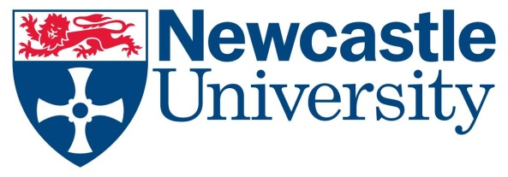
Musculoskeletal Research Group
Institute of Cellular Medicine
Newcastle University
The Medical School
Framlington Place
Newcastle upon Tyne
NE2 4HH United Kingdom

